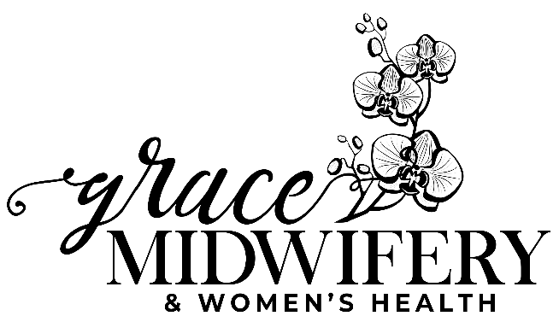

Acceptance of Blood Products

At Grace Midwifery & Women’s Health we strive for optimum health and to preserve life.

In the case of a life-threatening emergency, it is our policy to transfuse with blood if it is necessary to save your life.

Please sign on of the below:

I understand and agree with the above transfusion policy.

_______________________________________ ____________________________________ ___________________
Print Name Signature Date

I disagree and will be transferring my care elsewhere.
________________________________________ ____________________________________ __________________
Print Name Signature Date

________________________________________ __________________
Witness Signature Date

